**DARKO OFFEI JEFFERY**

**ACADEMIC TRANSCRIPT**

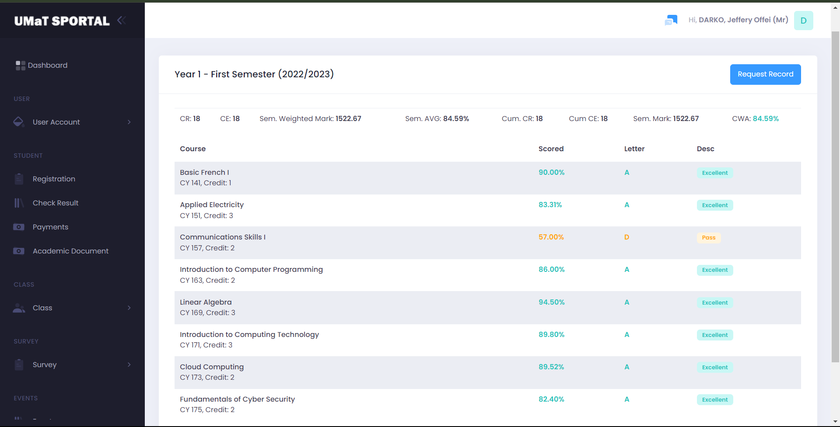

First Semester Results

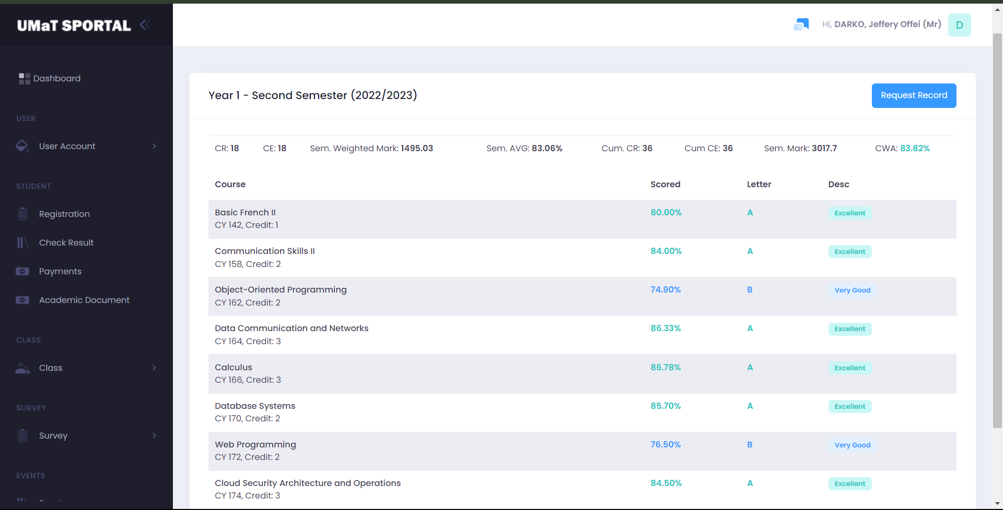

Second Semester Results